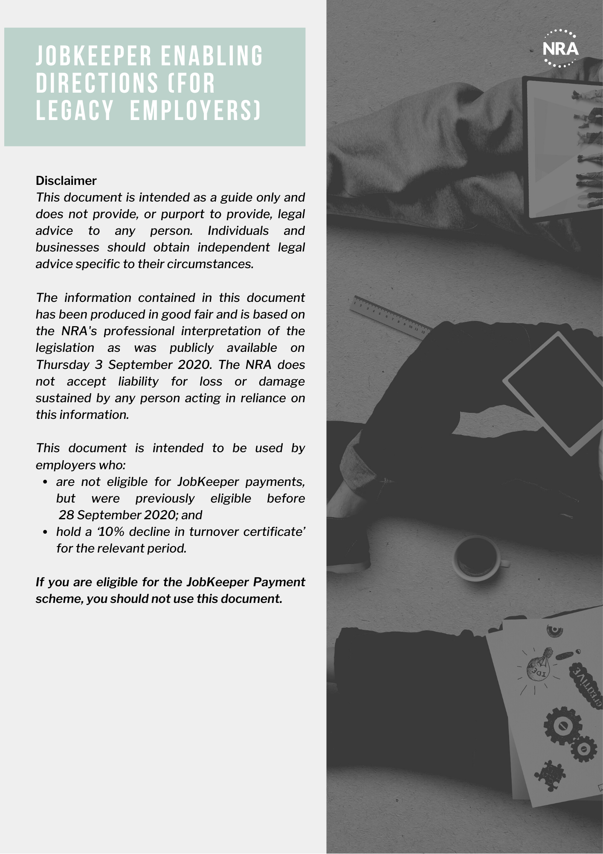
NOTICE OF INTENTION TO GIVE A JOBKEEPER ENABLING DIRECTION TEMPLATE
*FOR LECACY EMPLOYERS*
[INSERT COMPANY LETTERHEAD]
[DATE]
[ADDRESS LINE 1]
[ADDRESS LINE 2]
[ADDRESS LINE 3]

Dear [employee],
RE: Notice of intention to give a JobKeeper enabling direction
It is the intention of [insert company name] (we, us) to give you a JobKeeper enabling direction on [insert a date that is at least 7 days after the date that this notice is issued].
A copy of the direction that we intend to give is enclosed.
DELETE THIS TEXT BEFORE ISSUING: Please ensure that you enclose one of the template directions provided on the following pages when issuing this letter to your employee/s.
We would like to consult with you, or your duly appointed representatives, about the proposed direction.
You or your chosen representative are invited to attend a [meeting/phone call/online meeting] on [insert date] where [insert company name] would like to hear your views and any concerns you have about the above proposed changes.
[Insert company name] will give consideration to your views before making any decision as to whether to issue you with a JobKeeper enabling direction.

[SIGNATURE BLOCK]

NOTE: This written notice must be given to the employee at least 7 days before the direction is given or any lesser period of time genuinely agreed to by the employee.

JOBKEEPER ENABLING STAND DOWN DIRECTION – REDUCED HOURS – TEMPLATE
*FOR LECACY EMPLOYERS*
[INSERT COMPANY LETTERHEAD]
[DATE]

[ADDRESS LINE 1]
[ADDRESS LINE 2]
[ADDRESS LINE 3]

Dear [employee],

RE: JobKeeper enabling stand down direction
The COVID-19 pandemic and/or government initiatives to slow the transmission of COVID-19 has resulted in [insert company name] being unable to usefully employ you for your usual days and/or hours of work.
As such [insert company name] has made the necessary decision to issue you with a JobKeeper enabling stand down direction.
In accordance with section 789GJA(1) of the Fair Work Act 2009 (Cth) this is a direction to: [delete whichever of the following numbered paragraphs are not applicable to the employee]:
NOTE: This direction must not result in the employee working less than 60% of an employee’s ordinary hours of work as assessed at 1 March 2020, or less than two (2) consecutive hours in a day.
- not perform work on the following days that you would usually work: [insert an ‘X’ in the boxes of the days the employee would ordinarily work but will no longer work]
Monday | Tuesday | Wednesday | Thursday | Friday | Saturday | Sunday

- only perform work between the following times on the days that you will perform work: [insert the times that the employee will work going forward]
 | Monday | Tuesday | Wednesday | Thursday | Friday | Saturday | Sunday
Start
Finish

- work a reduced number of hours a week/fortnight/month [select whichever is applicable depending upon the applicable rostering system] totaling X hours a week/fortnight/month.
For the period of this intended direction, you will be paid your usual pay for any hours that you work. Your hourly base pay rate will not be reduced during this period.
You will continue to accumulate leave as normal during your period of reduced hours. While you are taking authorised paid or unpaid leave (such as annual leave) or are otherwise entitled to be absent from work (such as on a public holiday), the direction won’t apply. During these periods, you will be paid as normal.
This direction will continue until the end of 28 March 2021 unless [insert company name] ceases to hold a ‘10% decline in turnover certificate’, or the direction is otherwise replaced, revoked, or withdrawn.
If you have any questions about the matters raised above please do not hesitate to contact me.
[SIGNATURE BLOCK]
JOBKEEPER ENABLING DIRECTION AS TO DUTIES/LOCATION – TEMPLATE
*FOR LECACY EMPLOYERS*
[INSERT COMPANY LETTERHEAD]
[DATE]

[ADDRESS LINE 1]
[ADDRESS LINE 2]
[ADDRESS LINE 3]

Dear [employee],

RE: JobKeeper enabling direction as to [duties and/or location of work] [delete those that do not apply]
The COVID-19 pandemic and/or government initiatives to slow the transmission of COVID-19 has resulted in [insert company name] being unable to usefully employ you to perform your [usual duties/at your normal place of work]. [delete those that do not apply]
As such [insert company name] has made the necessary decision to issue you with a JobKeeper enabling direction under [section/s] 789GJB (duties of work) and 789GJC (location of work) of the Fair Work Act 2009 to: [delete those that do not apply]
- perform the following duties that are within your levels of skill and competency to perform safely:

- [list the duties that the employee is to perform]
You are not directed to perform any of the above duties if you do not possess the required license or qualification needed in order to perform those duties.
- perform your duties at [insert name of place if different from the employee’s normal place of work, which may include the employee’s home].
This direction will continue until the end of 28 March 2021 unless [insert company name] ceases to hold a ‘10% decline in turnover certificate’, or the direction is otherwise replaced, revoked, or withdrawn.
If you have any questions about the matters raised above please do not hesitate to contact me.
[SIGNATURE BLOCK]

NOTICE OF CONTINUATION OF JOBKEEPER ENABLING DIRECTION TEMPLATE
*FOR LECACY EMPLOYERS*
[INSERT COMPANY LETTERHEAD]
[DATE]
[ADDRESS LINE 1]
[ADDRESS LINE 2]
[ADDRESS LINE 3]

Dear [employee],
RE: Notice of continuation of JobKeeper enabling direction
I am writing to confirm that the JobKeeper enabling direction given to you on [insert date] will continue to apply to you on and after [28 October 2020/28 February 2021 [delete those that do not apply] as [insert company name] has obtained a ‘10% decline in turnover certificate’ for the [September/December] [delete those that do not apply] quarter confirming that we continue to satisfy the 10% decline in turnover test required.
This direction will continue until the end of 28 March 2021 unless [insert company name] ceases to hold a ‘10% decline in turnover certificate’, or the direction is otherwise replaced, revoked, or withdrawn.
As a result, your [hours/location/duties] of work will therefore remain as follows:
[insert the details of the direction previously given]
If you have any questions about the matters raised above please do not hesitate to contact me.

[SIGNATURE BLOCK]

NOTICE OF CESSATION OF JOBKEEPER ENABLING DIRECTION TEMPLATE
*FOR LECACY EMPLOYERS*
[INSERT COMPANY LETTERHEAD]
[DATE]
[ADDRESS LINE 1]
[ADDRESS LINE 2]
[ADDRESS LINE 3]

Dear [employee],
RE: Notice of cessation of JobKeeper enabling direction
I am writing to confirm that the JobKeeper enabling direction given to you on [insert date] will cease to apply to you on and after [28 October 2020/28 February 2021] [delete those that do not apply] as [insert company name] has not obtained a ‘10% decline in turnover certificate’ for the [September/December] [delete those that do not apply] quarter.
As a result, your [hours/location/duties] [delete those that do not apply] of work will therefore revert to your usual hours [hours/location/duties] [delete those that do not apply] of work from [28 October 2020/28 February 2021] [delete those that do not apply].
If you have any questions about the matters raised above please do not hesitate to contact me.

[SIGNATURE BLOCK]

